Contents
SLA 1
IAAS PAAS SAAS 1
Regions & Availability zones 3
Network basicst 4
Basic Security Principles (Confidentiality, Integrity, Availability) – The CIA Triad in Azure 4
Identity and Access Management (IAM) in Azure 5
Data Encryption Practices in Azure 6
Deployment 6
Azure Pricing Models – The 4 Core Concepts 8
Service bus explorer 10
Service Bus 10
Topics and subscriptions 11
Receive modes 11
Filter actions 12
Protocols: 12
Optimization 13
What are limitations of Azure Functions? 14

SLA
https://azurecharts.com/sla

IAAS PAAS SAAS
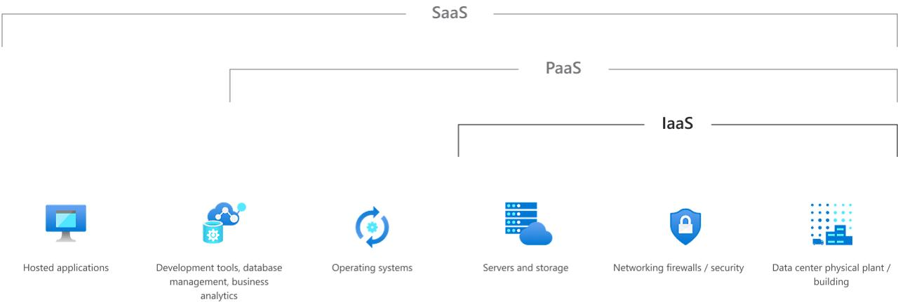
1. IaaS (Infrastructure as a Service)
raw computing infrastructure — virtual machines, storage, networks — and manage everything above the hardware layer (OS, middleware, apps, data).
Azure Examples:
- Azure Virtual Machines (VMs)
- Azure Virtual Network (VNet)
- Azure Blob Storage / Disk Storage

2. PaaS (Platform as a Service):
You get a ready-to-use development and deployment platform. Focus on writing code and deploying apps — no OS or server management.
You manage:
- Application code
- Data
Examples
- Azure App Service
- Azure SQL Database
- Azure Functions
- Azure Kubernetes Service (AKS)

3. SaaS (Software as a Service)
You use fully built software over the internet. No installation, no infrastructure, no development.
You manage:
- User accounts, permissions, data input
Examples

- Microsoft 365 (Office 365)
- Dynamics 365
- Power BI Service
- GitHub

Regions & Availability zones

Regions = geographical regions that include availability zones.
Availability zones include datacenters.
Availability zones are typically separated by several kilometers, and usually are within 100 kilometers.
- Zone-redundant deployments: resources are replicated or distributed across multiple availability zones automatically.
- Zonal deployments: A zonal resource is deployed to a single, self-selected availability zone.
Inter-zone latency
Within each region, availability zones are connected through a high-performance network with round-trip latency of less than approximately 2 milliseconds.
Availability zone architectural guidance
- Production workloads should be configured to use multiple availability zones if the region they are in supports availability zones.
- For mission-critical workloads, you should consider a solution that is both multi-region and multi-zone.

Monitoring and observability

- Monitoring tells you "What is happening." –
  - "The CPU usage on the database is at 95%."
- Observability allows you to ask "Why is it happening?"
  - "The CPU is high because a specific API call from the 'Checkout' microservice is running an unoptimized SQL query."
2. Azure Monitor
A. Metrics (Numerical Data)
- What they are: Lightweight, numerical values measured over time (e.g., CPU usage, memory available, request count).
- Characteristics: Real-time, low storage cost, great for triggering alerts.
- Use Case: "Alert me if the server response time exceeds 2 seconds."
B. Logs (Text/Structured Data)
- What they are: Records of events that occurred within the system (e.g., error messages, SQL query text, firewall allows/denies).
- Characteristics: Rich context, higher storage cost, queried using KQL (Kusto Query Language).
- Use Case: "Search for all error logs involving User ID 12345 between 2 PM and 3 PM."
3. Key Azure Observability Tools
1. Core (The Backend)
These are the fundamental services that collect and store the data.
- Azure Monitor: The overarching service that collects metrics and logs from all resources.
- Log Analytics Workspace: The database where logs are stored. This is where you run KQL queries.
- Azure Monitor Metrics: The time-series database for numerical data (CPU, RAM, IOPS).
2. Application Layer (Code & User Experience)
Tools to monitor your code, APIs, and user browser experience.
- Application Insights: The standard APM (Application Performance Monitoring) tool. It monitors request rates, response times, failure rates, and exceptions in code (Java, .NET, Node, Python, etc.).
- Digital Experience Monitoring (DEM): Used to verify that your application is reachable from the outside world.
  - Standard Tests: Pings your URL from different global locations.
  - Multi-step Web Tests: Simulates a user clicking through a specific flow (e.g., Login -> Search -> Cart).
3. Infrastructure Layer (Compute & Containers)
Tools to monitor the servers and clusters running your apps.
- VM Insights: Monitors Azure Virtual Machines (and on-prem servers via Azure Arc). It maps running processes and network dependencies between servers.
- Container Insights: Specifically for Azure Kubernetes Service (AKS), Azure Container Instances, and Arc-enabled Kubernetes. It provides logs for STDOUT/STDERR, pod status, and node health.
- Change Analysis: Detects changes made to the infrastructure (e.g., someone changed a firewall rule or resized a VM) and correlates them with issues.
4. Network Layer (Connectivity)
Tools to analyze traffic flow, latency, and connectivity.
- Network Watcher: The main suite for network diagnostics.
  - IP Flow Verify: Checks if a packet is allowed or denied to/from a specific IP.
  - Next Hop: Tells you where traffic is going next (to verify routing tables).
  - Packet Capture: Captures raw packet data for deep inspection (like Wireshark).
- NSG Flow Logs: Logs information about IP traffic flowing through Network Security Groups (NSGs).
- Traffic Analytics: Visualizes the NSG Flow Logs to show you a map of where traffic is coming from globally and identifies hotspots.
- Connection Monitor: Monitors connectivity between two points (e.g., from a VM in East US to a SQL DB in West Europe) over time to detect latency degradation.
5. Database & Storage Layer
Tools specialized for data services.
- SQL Insights (Preview): Advanced monitoring for Azure SQL Database and SQL Managed Instances.
- Storage Insights: specialized views for Azure Storage accounts (latency, capacity, and transaction failures).
- Cosmos DB Insights: detailed throughput, request unit (RU) consumption, and storage usage for Cosmos DB.
6. Security Layer
Tools that monitor for threats rather than performance.
- Microsoft Sentinel: A cloud-native SIEM (Security Information and Event Management). It analyzes logs to detect attacks, malware, and suspicious behavior.
- Microsoft Defender for Cloud: monitors the security posture of your resources (e.g., "Port 22 is open to the internet," "SQL encryption is off").
7. Visualization (The Front-End)
Tools to display the data collected by the tools above.
- Azure Workbooks: The most powerful native visualization tool. It allows you to combine text, queries, and charts into interactive reports.
- Azure Dashboards: The standard drag-and-drop dashboarding tool for the Azure Portal home screen.
- Azure Managed Grafana: A fully managed instance of Grafana (open source) for users who prefer Grafana over Azure-native visualizations.
- Power BI: Can import data from Azure Monitor for executive-level reporting.
8. Azure Platform Health (Global Status)
Tools that tell you if the problem is you, or if the problem is Microsoft.
- Azure Service Health: Notifies you of global Azure outages affecting your specific regions.
- Resource Health: A checkmark system for every individual resource (e.g., "Is my specific VM up or down according to the Azure hypervisor?").
- Azure Advisor: Analyzes your configuration and recommends changes for High Availability, Security, Performance, and Cost.
9. Cost Monitoring
- Azure Cost Management & Billing: Monitors your spend. You can set "Budgets" to trigger alerts if your spending speed exceeds a certain threshold.

Network basicst
- Virtual network
- Subnet (a range of IPs within the virtual network)
- Security groups – a set of rules for services communications
- VPN - a secured tunnel between specific addresses.
- Azure Traffic Manager & Front Door
- Availability Zones & Regions

Basic Security Principles (Confidentiality, Integrity, Availability) – The CIA Triad in Azure
The CIA Triad forms the foundation of information security. Azure implements these principles through layered services, policies, and controls.

Confidentiality
Ensures that data is accessible only to authorized entities.
- Azure Key Vault: Centralized storage for secrets (passwords, API keys), certificates, and cryptographic keys. Uses Hardware Security Modules (HSMs) for FIPS 140-2 Level 2/3 compliance. Access is controlled via Azure RBAC and Managed Identities.
- Azure Information Protection (AIP) / Microsoft Purview Information Protection: Classifies and labels sensitive data (e.g., PII, financials). Applies persistent encryption and visual markings. Integrates with Microsoft 365 and Azure Blob Storage.
- Private Endpoints & VNet Integration: Azure services (e.g., Storage, SQL) can be exposed only within a Virtual Network, blocking public internet access.
- Azure Disk Encryption (ADE): Uses BitLocker (Windows) or DM-Crypt (Linux) with keys stored in Key Vault. Ensures data at rest in VMs is encrypted.
- Transport Layer Security (TLS): Enforced by default on Azure App Services, API Management, and Front Door. Azure enforces TLS 1.2+.
Integrity
Ensures data is accurate and unaltered.
- Azure Storage Service Encryption: Automatically encrypts data at rest using 256-bit AES. Supports customer-managed keys (CMK) for integrity verification via Key Vault.
- Immutable Blobs (WORM – Write Once Read Many): In Azure Blob Storage, enables time-based or legal hold policies. Prevents deletion/modification even by storage account owners.
- Azure SQL Database Ledger: Blockchain-inspired feature using cryptographically attestable tables. Ensures tamper-evidence for audit-critical data.
- Hashing & Digital Signatures: Azure Content Delivery Network (CDN) and Azure Functions support SRI (Subresource Integrity) and signed URLs with shared access signatures (SAS) using HMAC-SHA256.
- Azure Policy & Blueprints: Enforce configuration standards (e.g., “all VMs must have disk encryption”). Uses hash-based compliance checks.
Availability
Ensures systems and data are accessible when needed.
- Availability Zones & Regions: Deploy resources across physically separate datacenters within a region (zones) or across regions. SLA for VMs: 99.99% (zone-redundant).
- Azure Traffic Manager & Front Door: Global DNS-based routing with health probes. Supports failover in <1 minute.
- Azure Backup & Site Recovery: Automated backups with geo-redundant storage (GRS). Site Recovery orchestrates VM failover to secondary regions.
- DDoS Protection Standard: Layer 3–7 mitigation with adaptive tuning based on traffic patterns.
- Load Balancers (Azure LB, Application Gateway): Distribute traffic with health probes and session affinity.

Identity and Access Management (IAM) in Azure
Azure IAM is built on Azure Active Directory (Azure AD, now Microsoft Entra ID) and Azure Role-Based Access Control (RBAC).Core Components
Component | Purpose | Azure Example
Azure AD | Centralized identity provider | SSO for 5,000+ SaaS apps, MFA, Conditional Access
Users & Groups | Identity objects | john@contoso.com, Finance-Team security group
Service Principals / Managed Identities | Non-human identities | App registrations, System-assigned MI for VMs
RBAC Roles | Permission sets | Contributor, Reader, Storage Blob Data Owner
Azure AD PIM | Just-in-time access | Elevate to Global Admin for 4 hours only
Key IAM Features with Examples
- Conditional Access Policies
  - Block login from untrusted locations:
{ "conditions": { "locations": { "exclude": ["trusted IPs"] } }, "grant": ["block"] }
  - Require MFA for admins accessing Key Vault.
- Privileged Identity Management (PIM)
  - Eligible role: Owner → Activate for 1–8 hours → Audit log in Azure AD.
- Managed Identities
  - VM authenticates to Key Vault without credentials:
az vm identity assign -g RG -n MyVM
az keyvault set-policy --name MyVault --object-id <MI-principal> --secret-permissions get
- Custom RBAC Roles
  - Allow only restarting VMs:
"actions": ["Microsoft.Compute/virtualMachines/start/action", "Microsoft.Compute/virtualMachines/restart/action"],
"notActions": ["Microsoft.Compute/virtualMachines/*"]
- Scope Levels
  - Management Group → Subscription → Resource Group → Resource
  - Assign Reader at subscription = inherited by all resources.
- Azure AD B2C / B2B
  - B2C: Customer-facing apps (e.g., login with Google).
  - B2B: Invite external partners (guest@partner.com).

Data Encryption Practices in Azure
Azure uses encryption at rest, in transit, and in use.
Service | Method | Key Management
Azure Storage | SSE with 256-bit AES | Microsoft-managed (default) or Customer-managed (CMK in Key Vault)
Azure SQL | TDE with AES-256 | Service-managed or BYOK (Bring Your Own Key)
VM Disks | ADE (BitLocker/DM-Crypt) | Keys in Key Vault; supports double encryption
Cosmos DB | Always-on AES-256 | Microsoft-managed only
- Customer-Managed Keys (CMK): Rotate, revoke, audit via Key Vault. Automatic key rotation policy (e.g., every 90 days).
Encryption in Transit
- TLS 1.2+ enforced by default.
- Azure VPN Gateway: IPsec/IKEv2 with Perfect Forward Secrecy (PFS).
- ExpressRoute: Optional MACsec encryption (line-rate on 100 Gbps).
Encryption in Use (Confidential Computing)
- Azure Confidential VMs (Intel SGX, AMD SEV-SNP):
  - Enclave memory encrypted even from hypervisor.
  - Example: Run ML model on sensitive data without exposing it.
Advanced Encryption Scenarios
- Always Encrypted (SQL): Client-side encryption. Application encrypts before sending to DB.
CREATE COLUMN ENCRYPTION KEY ... WITH VALUES (COLUMN_MASTER_KEY = MyCMK, ALGORITHM = 'RSA_OAEP')
- Double Encryption:
  - Infrastructure-level (Azure-managed) + Service-level (CMK).
- Key Rotation & Revocation:
  - Revoke Key Vault key → immediate access denial to dependent resources.
  - Soft-delete + purge protection (7–90 days).
- Tokenization (via Microsoft Purview): Replace SSN with token, store mapping in secure vault.

Deployment
Full: https://www.harness.io/blog/difference-between-rolling-and-blue-green-deployments
RU – equivalent of strangler pattern, Canary – release to a subset of users, then to all, blue-green – set up 2 envs and reroute traffic to a new one after update
Rolling Updates(Deployment)
The new version of an application is gradually deployed across servers or containers, such as Docker instances, replacing the old version incrementally. This process involves updating a subset of servers at a time, rather than updating all servers simultaneously. It allows for the application to run different versions briefly during the deployment process. This approach minimizes downtime and reduces the impact on end users, as there’s always a version of the application available to serve user requests. However, managing different versions during the rollout can be complex, especially with database changes.

How rolling deployments work
Scenario, usually managed by an orchestration tool like Kubernetes:
- Preparation: The new version of the application is containerized and ready for deployment.
- Initial Rollout: The deployment starts with one (or a small group) of instances being taken out of the service pool by the load balancer. These instances are then updated to the newer version.
- Health Checks: After the update, health checks are performed to ensure that the new instance meets all operational criteria and does not introduce any new issues.
- Gradual Rollout: If the health checks pass, the updated instance is reintroduced to the pool of service instances, and the load balancer begins routing traffic to it. The process is then repeated for the next set of instances until all instances are updated.
- Monitoring and Rollback: Throughout the rollout, the application is closely monitored. If issues are detected, the deployment can be halted, and a rollback to the previous version can be initiated.
This strategy relies heavily on automation tools and services, such as Kubernetes, which can manage the complexities of rolling updates, including the orchestration of updates, health checks, and rollbacks

Blue-Green Deployment
Involves maintaining two identical production environments, only one of which is live at any given time. When a new version of an application is ready for release, it is deployed to the inactive environment, which is then thoroughly tested and evaluated. Once the new version is verified to be stable, the traffic is switched from the old environment (blue) to the new environment (green), making the new version active and accessible to end users. This strategy allows for instant rollback if issues are detected by simply switching back to the blue environment. Blue-green deployment is particularly effective in reducing downtime and risk as it provides a straightforward way to switch between different versions. However, it requires double the resources since two environments must be maintained simultaneously.
The Process of Blue-Green Deployment
- Preparation: Initially, both blue and green environments are set up to be identical in terms of hardware, software, and configuration. This includes databases, application servers, and any other required services.
- Deployment: When a new version of the software is ready for release, it is deployed to the idle environment (let’s say green if blue is currently live). This deployment includes all necessary updates, migrations, and configurations needed for the new version.
- Testing: The green environment, now hosting the new version, undergoes thorough testing and verification. This phase is crucial for ensuring that the new release meets all quality and performance standards without affecting the user experience negatively.
- Switching Traffic: Once the new version in the green environment is verified to be stable and ready for production, the traffic is switched from the blue environment to the green environment. This is often achieved using a load balancer or DNS switch, redirecting all user traffic to the green environment seamlessly.
- Monitoring: After the switch, the new live environment (green) is closely monitored to ensure that it operates as expected under full load. Any anomalies or issues are addressed immediately.
- Rollback: If any critical issues are discovered after the switch, the system can quickly revert to the previous version by switching traffic back to the blue environment, which remains intact and operational.
- Cleanup and Preparation for Next Release: Post-switch, the now idle blue environment is updated with the new version in preparation for the next deployment cycle. This ensures that both environments are again identical, ready for the next blue-green switch.

Canary Deployment
A new version of the application is rolled out to a small subset of users before it’s made available to the entire user base. This strategy allows teams to monitor metrics and performance indicators to ensure the new version operates as expected in the production environment. If issues are detected, the process includes mechanisms for a quick rollback to the previous version, minimizing the impact on users.

Azure Pricing Models – The 4 Core Concepts
Model | What it means | Typical Services | Billing Trigger
Pay-as-you-go (PAYG) | Pay only for what you use, per second/minute/hour | VM, App Service, Functions, Storage (hot) | Runtime / GB transferred
Reserved Instances (RI) | Commit 1- or 3-year, get 40-75 % discount | VMs, SQL DB, Cosmos DB, App Service | Upfront or monthly commitment
Spot VMs | Bid on unused capacity, up to 90 % off, can be evicted | Batch jobs, dev/test | When Azure needs capacity
Savings Plan (newer than RI) | Commit to $ per hour spend (any region/service), up to 65 % off | Any compute (VM, Functions, AKS, etc.) | Hourly spend commitment
Interview Tip:
“RI = service-specific & region-locked. Savings Plan = flexible across services & regions.”

Azure Spot VMs Azure Spot Virtual Machine Instances Guide – Spot Instances 101 - Umbrella
Spot VMs = Azure sells unused capacity at a steep discount (up to 90 %).
You bid a max price (or accept current spot price).
If Azure needs the capacity back, it evicts your VM with 30-second warning.
Use Cases | Batch, ML training, CI/CD, rendering, dev/test
Not for | Production web apps, stateful DBs
Pricing | Dynamic – changes per region/sku (view in portal or CLI)
Eviction types:
- Capacity eviction (Azure needs hardware) → most common
- Price eviction (your max < current spot price)
Spot VM Best Practices
Practice | Why
Use Deallocate (not Delete) | Restart later, save disk cost
Idempotent workloads | Retry on failure
Azure Batch / AKS Spot node pools | Built-in retry + scaling
Monitor spot price history | az vm list-spot-prices

Interview Answer (60 sec)
“Spot VMs let us run non-critical workloads on spare capacity at up to 90 % off. I use them for ML training and CI/CD runners. For example, a D4s v5 costs $0.384/hr PAYG but only $0.04–$0.06 on Spot. We set --eviction-policy Deallocate and use Azure Batch to auto-restart jobs. Risk: 30-sec eviction, so never for stateful apps.”

Azure Savings Plans – Full Details + Example
If you consistently spend at least $X every hour, but your usage comes from different resources and/or different datacenter regions, you likely can't effectively cover these costs with reservations. When you buy a savings plan, your hourly usage, up to your commitment amount, is discounted. For this usage, you no longer charged at the pay-as-you-go rates. Get discount on any compute usage (VMs, Functions, AKS, App Service, etc.) across regions and services.
Discount | Up to 65 % vs PAYG
Flexibility | Any compute service, any region
Commitment | $ per hour (e.g., $50/hr = ~$36K/yr)
Payment | Upfront, monthly, or PAYG
Better than RI when | Workloads vary in size, region, or service
RI = locked to one service + SKU + region
Savings Plan = flexible dollar commitment

Cost Optimization Strategies (Top 10 – Interview Gold)
# | Strategy | How to Apply | Expected Savings
1 | Right-size VMs | Use Azure Advisor → downsize over-provisioned VMs | 20-50 %
2 | Use B-series (burstable) | Dev/test, low-CPU workloads | 30-60 %
3 | Reserved Instances / Savings Plans | Commit to predictable workloads | 40-72 %
4 | Spot VMs | Non-critical batch/ML jobs | Up to 90 %
5 | Auto-scale | Scale to zero when idle (Functions, AKS) | 50-80 %
6 | Storage tiering | Hot → Cool → Archive (Lifecycle Policy) | 50-70 %
7 | Delete dev/test resources | Use Azure DevTest Labs or shutdown schedules | 100 % when off
8 | Use Azure Hybrid Benefit | Bring Windows/SQL licenses | Up to 85 % on VM
9 | Tag & allocate costs | Enforce tagging policy → chargeback | Better governance
10 | Use CDN / Front Door | Cache static content → reduce egress | 30-60 %
Pro Tip:
- Azure Advisor = free built-in optimizer (appears in portal)
- Cost Management exports → Power BI for CFO reports

Interview Questions
Question | 60-Second Answer
Q1: How do you estimate monthly cost for a web app with VM, SQL DB, and storage? | Use Pricing Calculator: add App Service Plan (P1v2), SQL DB (S3), 200 GB blob. Apply 1-yr RI on VM. Add 500 GB egress. Export → $320/mo. Validate in Cost Management after deploy.
Q2: A VM is running 24×7 but used only 9-5. How to save? | Enable auto-shutdown (via DevTest Labs or Automation Runbook) or scale set with capacity 0 at night. Save ~60 % ($0 → overnight).
Q3: RI vs Savings Plan? | RI = locked to VM size/family/region, up to 72 % off. Savings Plan = $ per hour commitment, flexible across compute services, up to 65 %. Use Savings Plan for mixed workloads.
Q4: How to prevent cost surprises? | Set budgets with alerts in Cost Management. Use resource tags + Azure Policy to block unapproved regions/SKUs. Review Advisor weekly.
Q5: What is Azure Hybrid Benefit? | Use on-prem Windows Server or SQL Server licenses with Software Assurance → pay only base compute rate (Linux price) on Azure VMs or SQL DB. Saves up to 85 %.

Cost optimization techniques
- Tagging Strategy: You cannot optimize what you cannot measure. Tag every resource with CostCenter, Environment (Dev/Prod), and Owner.
- Find & Delete "Zombies":
  - Unattached Disks: Managed disks remain billable even after the VM is deleted.
  - Public IPs: Static IPs not associated with a running NIC incur costs.
  - Snapshots: Delete old backups that exceed your retention policy.
- Azure Hybrid Benefit: If you have on-premises Windows Server or SQL Server licenses with Software Assurance, use them in Azure to save ~40% on VM costs.

Virtual Machine Scale Sets (VMSS)
VMSS allows you to group identical VMs and scale them based on metrics.
- Cost Strategy: Mix Spot and Regular instances. You can configure a scale set to run your "base load" (e.g., 2 VMs) on Reserved Instances and scale out using Spot instances for the spikes.
- Autoscale Best Practice:
  - Scale Out: Aggressive. (e.g., If CPU > 70% for 5 mins, add 2 instances).
  - Scale In: Conservative. (e.g., If CPU < 25% for 15 mins, remove 1 instance). This prevents "flapping" (rapidly scaling up and down).
Azure Cosmos DB
- Autoscale Provisioned Throughput: You set a max RU/s (e.g., 4,000).[5][7] Cosmos DB automatically scales between 10% (400 RU/s) and 100% (4,000 RU/s) based on traffic.
  - Cost Warning: Autoscale RU/s cost 1.5x more per unit than standard provisioned throughput.[5][7][8] Only use it if your traffic varies unpredictably by more than 30-40%.
- Burst Capacity: Enabled by default. Allows you to use unused capacity from the last 5 minutes to handle short spikes without being throttled (429 errors).[9]
- Serverless: Best for very low traffic. You pay purely per Request Unit. No reserved capacity.

Service bus explorer
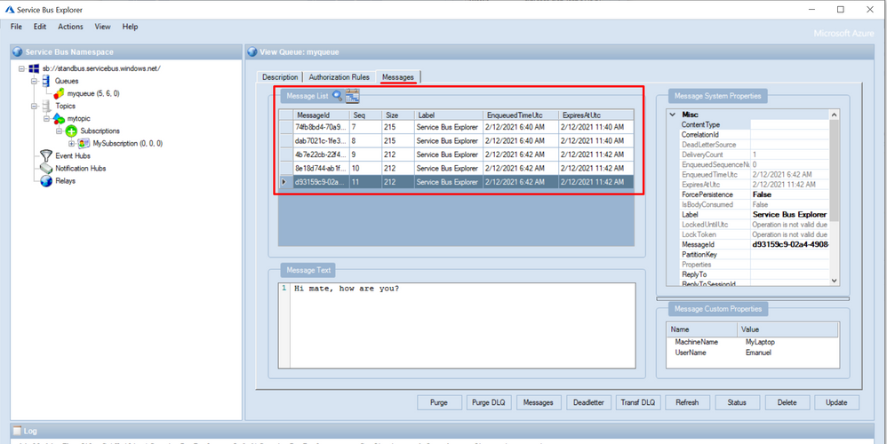

Service Bus
Queues offer First In, First Out (FIFO) message delivery to one or more competing consumers. That is, receivers typically receive and process messages in the order in which they were added to the queue. And, only one message consumer receives and processes each message.
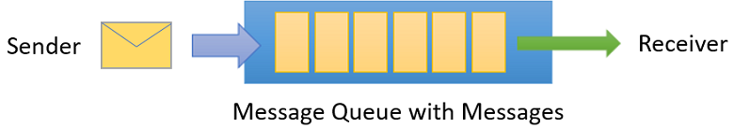

Topics and subscriptions
A queue allows processing of a message by a single consumer. In contrast to queues, topics and subscriptions provide a one-to-many form of communication in a publish and subscribe pattern. It's useful for scaling to large numbers of recipients. Each published message is made available to each subscription registered with the topic. Publisher sends a message to a topic and one or more subscribers receive a copy of the message.
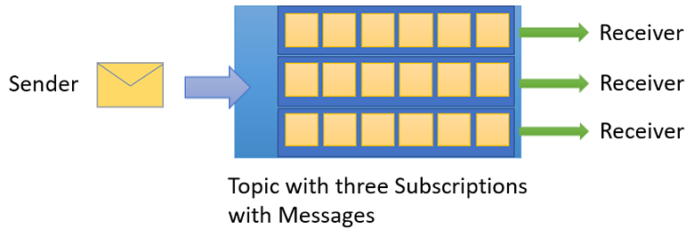

Receive modes
You can specify two different modes in which consumers can receive messages from Service Bus.
- Receive and delete.
when Service Bus receives the request from the consumer, it marks the message as being consumed and returns it to the consumer application. This mode is the simplest model. It works best for scenarios in which the application can tolerate not processing a message if a failure occurs. To understand this scenario, consider a scenario in which the consumer issues the receive request and then crashes before processing it. As Service Bus marks the message as consumed, the application begins consuming messages upon restart. It will miss the message that it consumed before the crash. This process is often called at-most once processing.
- Peek lock. In this mode, the receive operation becomes two-stage, which makes it possible to support applications that can't tolerate missing messages.
  - Finds the next message to be consumed, locks it to prevent other consumers from receiving it, and then, return the message to the application.
  - After the application finishes processing the message, it requests the Service Bus service to complete the second stage of the receive process. Then, the service marks the message as consumed.
If the application is unable to process the message for some reason, it can request the Service Bus service to abandon the message. Service Bus unlocks the message and makes it available to be received again, either by the same consumer or by another competing consumer. Secondly, there's a timeout associated with the lock. If the application fails to process the message before the lock timeout expires, Service Bus unlocks the message and makes it available to be received again.
If the application crashes after it processes the message, but before it requests the Service Bus service to complete the message, Servic

Filter actions
When a subscription is created, you can supply a filter expression that operates on the properties of the message. The properties can be both the system properties (for example, Label) and custom application properties (for example, StoreName.) The SQL filter expression is optional in this case. Without a SQL filter expression, any filter action defined on a subscription will be done on all the messages for that subscription.

Protocols:
- Advanced Message Queuing Protocol (AMQP)
- Service Bus Messaging Protocol (SBMP)
- Hypertext Transfer Protocol (HTTP)

Optimization
- Resource planning and considerations
- Protocols
- Reusing factories and clients
The Service Bus clients that interact with the service, such as ServiceBusClient, ServiceBusSender, ServiceBusReceiver, and ServiceBusProcessor, should be registered for dependency injection as singletons (or instantiated once and shared). ServiceBusClient can be registered for dependency injection with the ServiceBusClientBuilderExtensions.
- Concurrent operations
To increase the number of operations per time, operations must execute concurrently.
- Receive mode
When creating a queue or subscription client, you can specify a receive mode: Peek-lock or Receive and Delete. The default receive mode is PeekLock. When operating in the default mode, the client sends a request to receive a message from Service Bus. After the client has received the message, it sends a request to complete the message.
When setting the receive mode to ReceiveAndDelete, both steps are combined in a single request. These steps reduce the overall number of operations, and can improve the overall message throughput. This performance gain comes at the risk of losing messages.

- Batching store access
To increase the throughput of a queue, topic, or subscription, Service Bus batches multiple messages when it writes to its internal store.
- With batching on a queue, writing messages, and deleting messages are batched.
- With batching on a topic, writing messages into the store are batched.
- With on a subscription, deleting messages from the store are batched.
- When batched store access is enabled for an entity, Service Bus delays a store write operation for that entity by up to 20 ms.

There is no risk of losing messages with batching, even if there is a Service Bus failure at the end of a 20ms batching interval.
- Prefetching
Prefetching enables the queue or subscription client to load additional messages from the service when it receives messages. The client stores these messages in a local cache. The size of the cache is determined by the QueueClient.PrefetchCount or SubscriptionClient.PrefetchCount properties. Each client that enables prefetching maintains its own cache. A cache isn't shared across clients. If the client starts a receive operation and its cache is empty, the service transmits a batch of messages. The size of the batch equals the size of the cache or 256 KB, whichever is smaller. If the client starts a receive operation and the cache contains a message, the message is taken from the cache.

When a message is prefetched, the service locks the prefetched message. With the lock, the prefetched message can't be received by a different receiver. If the receiver can't complete the message before the lock expires, the message becomes available to other receivers. The prefetched copy of the message remains in the cache. The receiver that consumes the expired cached copy receives an exception when it tries to complete that message. By default, the message lock expires after 60 seconds. This value can be extended to 5 minutes. To prevent the consumption of expired messages, set the cache size smaller than the number of messages that a client can consume within the lock timeout interval.

When you use the default lock expiration of 60 seconds, a good value for PrefetchCount is 20 times the maximum processing rates of all receivers of the factory.
- Prefetching and ReceiveBatch
- Multiple queues or topics
- Partitioned namespaces
- Scenarios

What are limitations of Azure Functions?

Azure Functions is a serverless compute service provided by Microsoft Azure, and while it offers several benefits, it also has some limitations and constraints that you should be aware of:
- Execution Time Limitations: Azure Functions have execution time limits, which can vary based on the hosting plan. For example, in the Consumption Plan, the maximum execution time is 5 minutes. Long-running processes may not be suitable for Azure Functions without additional strategies like Durable Functions.
- Resource Constraints: Azure Functions run in a constrained environment with limited CPU and memory resources. While this is sufficient for many workloads, resource-intensive tasks may not perform well or may need to be optimized.
- Cold Start Latency: When a function is triggered after a period of inactivity, there can be a noticeable "cold start" delay as the runtime initializes. This can impact the responsiveness of serverless applications.
- State Management: Azure Functions are designed to be stateless, meaning they don't maintain state between invocations by default. Managing and sharing state across function invocations requires additional mechanisms or services.
- Limited Execution Environments: Azure Functions currently support a limited set of programming languages (e.g., C#, JavaScript, Python, PowerShell). If you need a language not supported, you may need to consider other compute options.
- Dependency Management: Managing dependencies and external libraries in Azure Functions can be challenging, especially for complex applications. Dependency management tools and strategies are necessary.
- Concurrency and Scaling: While Azure Functions automatically scale based on incoming requests, there can be limits on concurrent executions, especially in the Consumption Plan. You may need to adjust the hosting plan or use other Azure services for high-concurrency scenarios.
- Storage Constraints: Azure Functions rely on storage for triggers, bindings, and intermediate data. There can be storage-related costs and constraints, and you should design your functions with storage limitations in mind.
- Networking Limitations: Azure Functions have some networking constraints, including limited outbound connections and restrictions on certain network protocols. These limitations can affect communication with external services.
- Debugging and Monitoring: Debugging and monitoring serverless applications, including Azure Functions, can be more challenging compared to traditional applications. Azure provides tools like Application Insights for monitoring and logging.
- Limited Execution Environments: Azure Functions run in a predefined execution environment, which may lack some libraries, binaries, or configurations required for specific tasks. Customizing the execution environment can be challenging.
- No Direct Access to Infrastructure: In serverless environments like Azure Functions, you don't have direct access to the underlying infrastructure, which can limit certain system-level operations and customizations.
Despite these limitations, Azure Functions offer a powerful way to build event-driven, scalable, and cost-effective applications. To mitigate these limitations, it's essential to understand them thoroughly, design your applications accordingly, and consider other Azure services or compute options when necessary.

